**Digital Signal Processing Lab**

**Lab Report # 01**



Submitted By: **AWAIS SADDIQUI**

Registration No:  **21PWCSE1993**

Section: **“A”**

“On my honor, as student at University of Engineering and

Technology, I have neither given nor received unauthorized.

assistance on this academic work”

**Student Signature: ______________**

Submitted to:

**Sir Yasir Saleem Afridi**

**Department of Computer Systems Engineering**

**University of Engineering and Technology, Peshawar.**

**CSE 309L: Communication Systems**

|  |  |  |  |  |
| --- | --- | --- | --- | --- |
| **Demonstration of Concepts** | **Poor (Does not meet expectation (1))**  The student failed to demonstrate a clear understanding of the assignment concepts | **Fair (Meet Expectation (2-3))**  The student demonstrated a clear understanding of some of the assignment concepts | **Good (Exceeds Expectation (4-5)**  The student demonstrated a clear understanding of the assignment concepts | **Score**  **30%** |
| **Accuracy** | The student mis-configured enough signal processing settings that the computer couldn't function properly. | The student configured enough signal processing settings that the computer partially functioned | The student configured the signal processing settings that the computer fully functioned | **30%** |
| **Following Directions** | The student clearly failed to follow the verbal and written instructions to successfully complete the lab | The student failed to follow the some of the verbal and written instructions to successfully complete all requirements of the lab | The student followed the verbal and written instructions to successfully complete requirements of the lab | **20%** |
| **Time Utilization** | The student failed to complete even part of the lab in the allotted amount of time | The student failed to complete the entire lab in the allotted amount of time | The student completed the lab in its entirety in the allotted amount of time | **20%** |

1. **Course Overview:**
2. **Objective:** Familiarize yourself with the course.

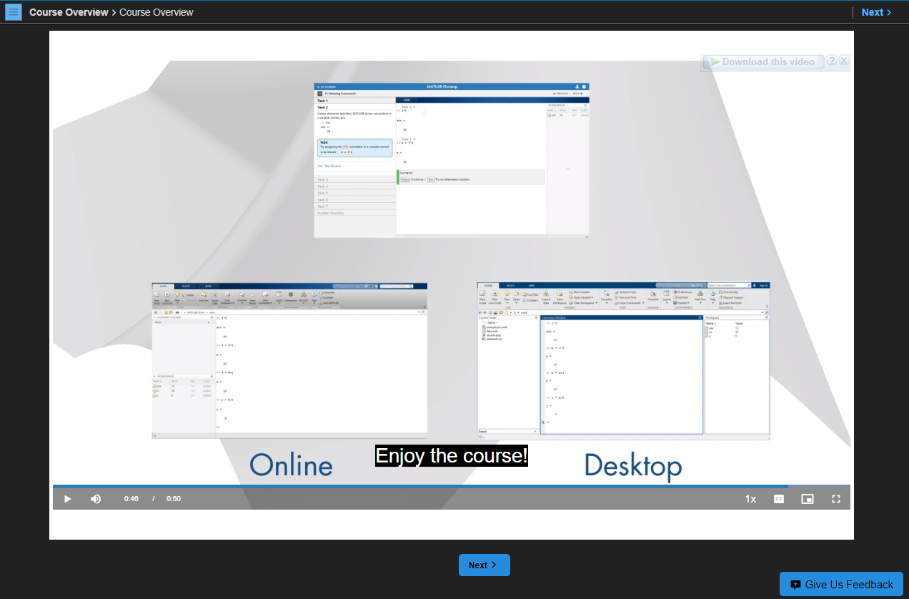

1. **Remarks:**

Introduction of MATLAB and it’s uses in real world problems.

1. **Commands:**
2. **Objective**: Enter commands in MATLAB to perform calculations and create variables.

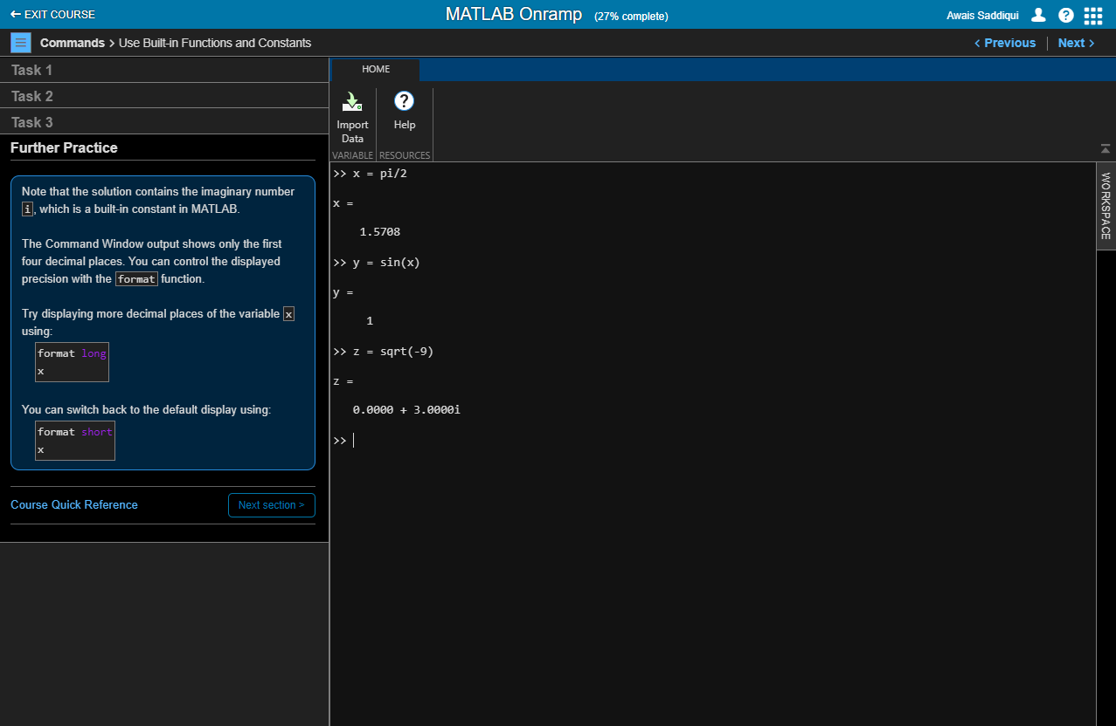

1. **Remarks**:

In this section, I learned how to enter commands in MATLAB. And how save and load variables also use built in functions and constants.

1. **Vectors and Matrices:**
   1. **Objectives**: Create MATLAB variables that contain multiple elements.

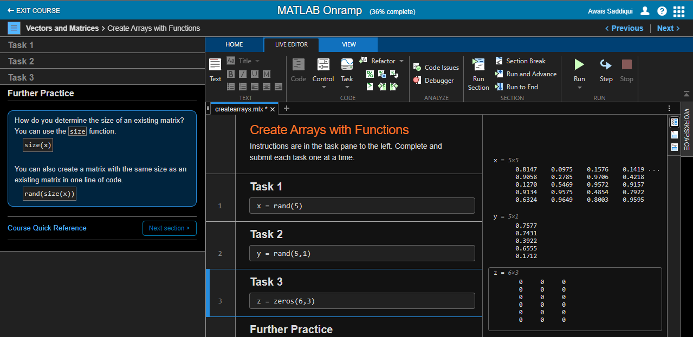

**Remarks**:

In this section, I learned how to enter manually arrays and creates arrays with functions.

1. **Importing Data:**
2. **Objective**: Bring data from external files into MATLAB.

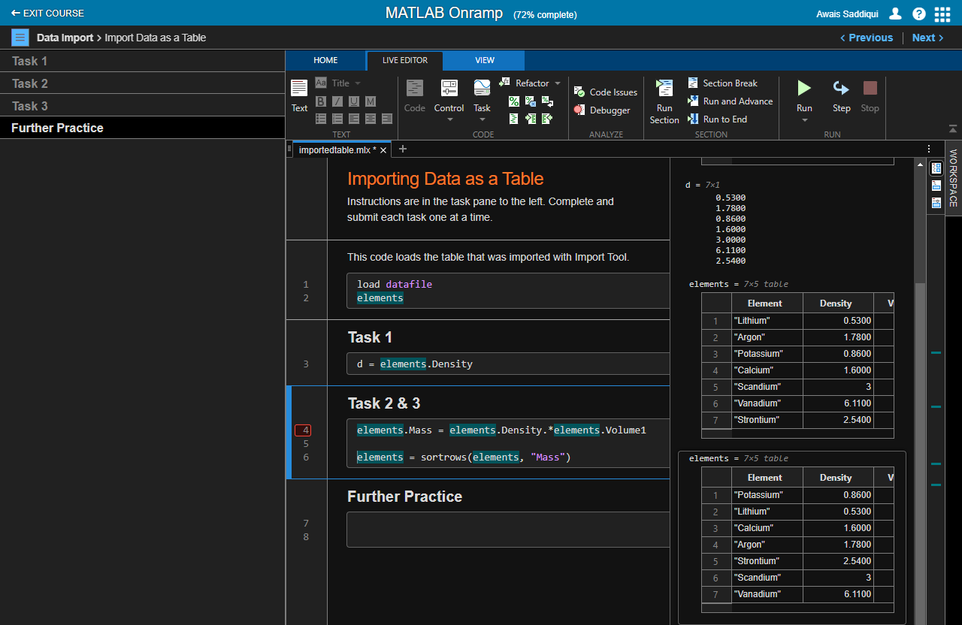

**Remarks**:

How to import data from external files to MATLAB.

1. **Indexing into and Modifying Arrays:**
2. Use indexing to extract and modify rows, columns, and elements of MATLAB arrays.

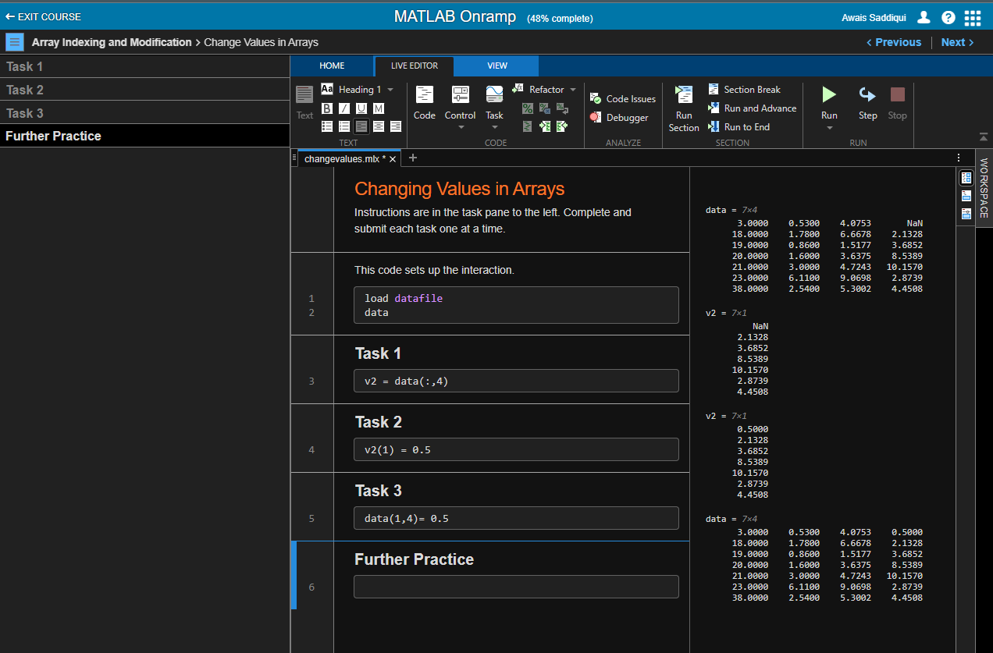

**Remarks**:

I learned indexing, index into arrays , extract multiple elements and change values in arrays.

1. **Array Calculations:**
2. **Objective**: Perform calculations on entire arrays at once.

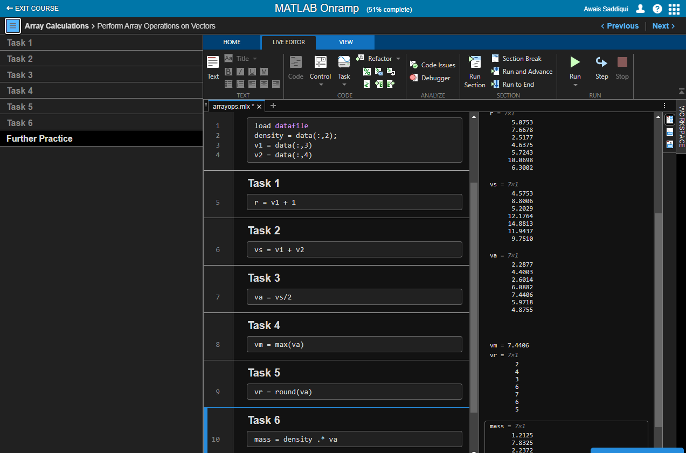

**Remarks**:

How to perform array operations on vectors.

1. **Calling Functions:**
2. **Objective**: Call functions to obtain multiple outputs.

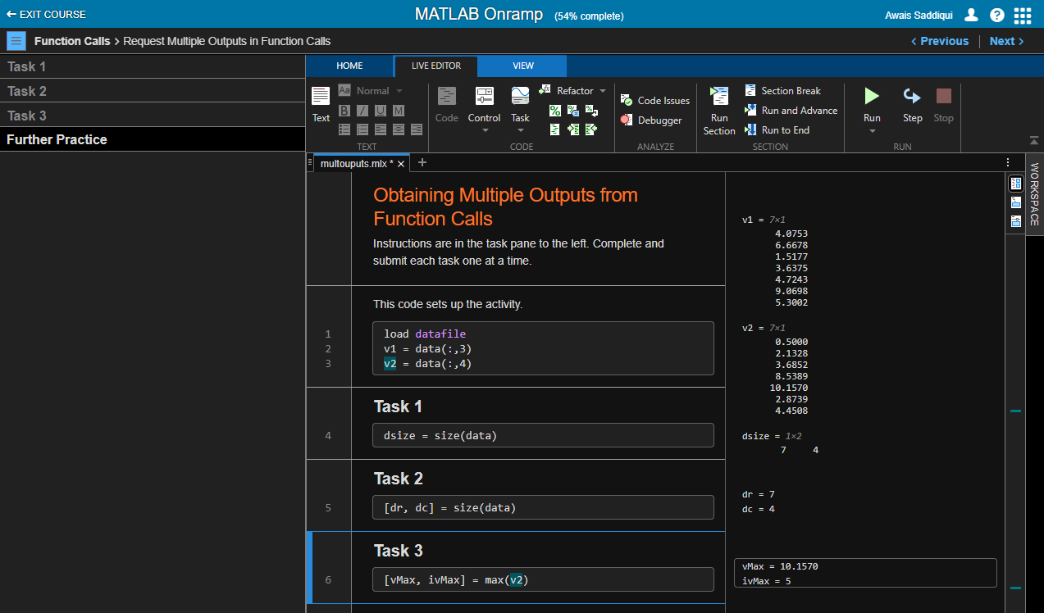

**Remarks**:

I learned, How to obtained multiple outputs from function calls.

1. **Obtaining Help:**

**Objective**: Use the MATLAB documentation to discover information about MATLAB features.

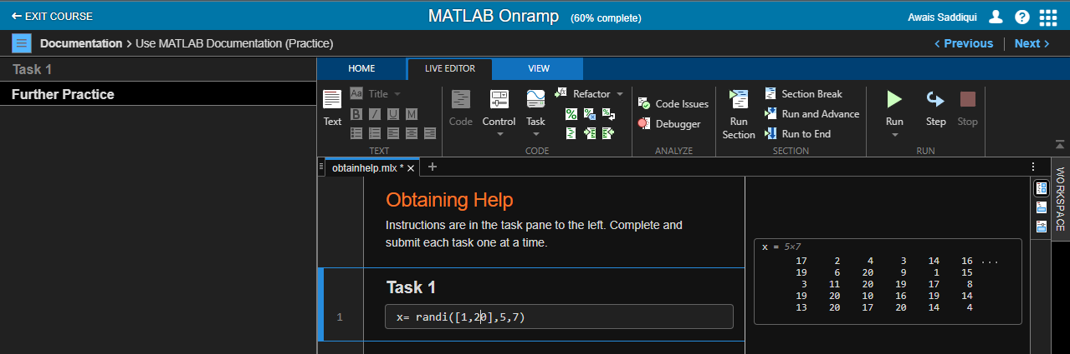

**Remarks**:

I learned how to MATLAB documentation.

1. **Plotting Data:**

Visualize variables using MATLAB's plotting functions.

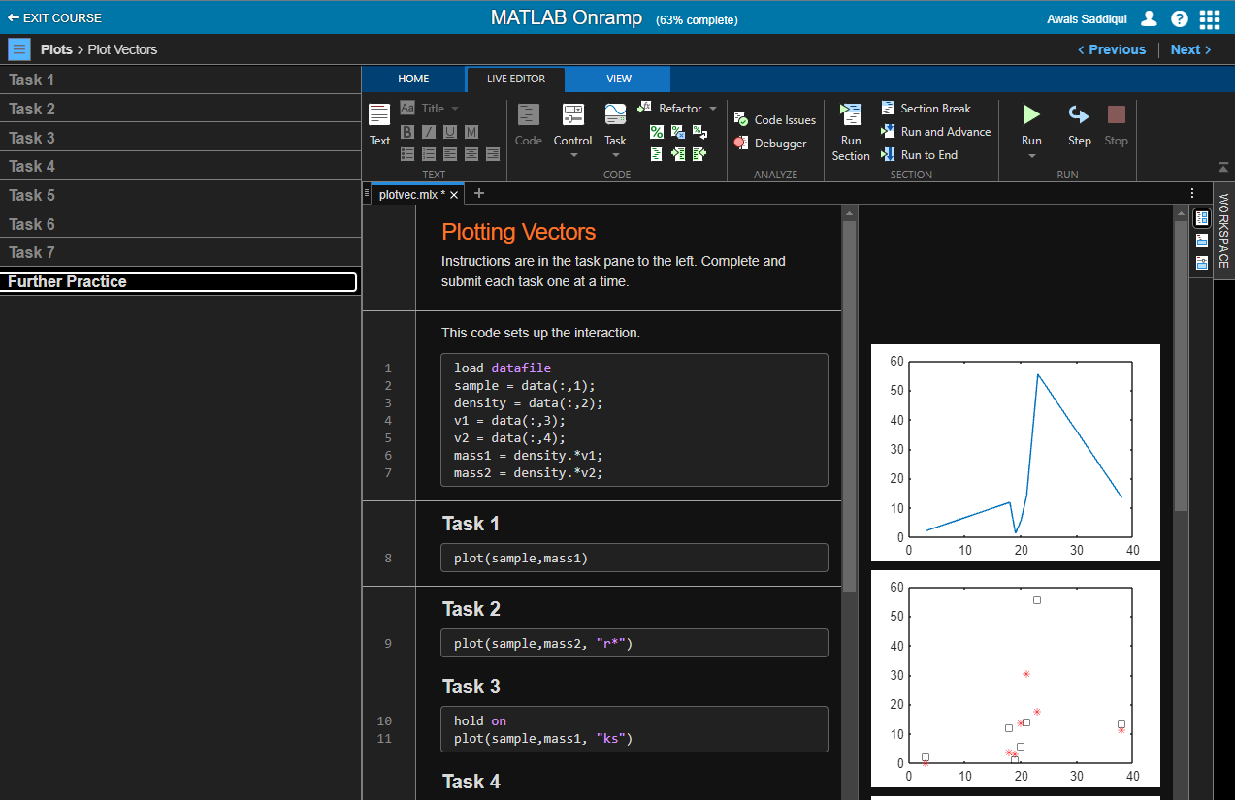

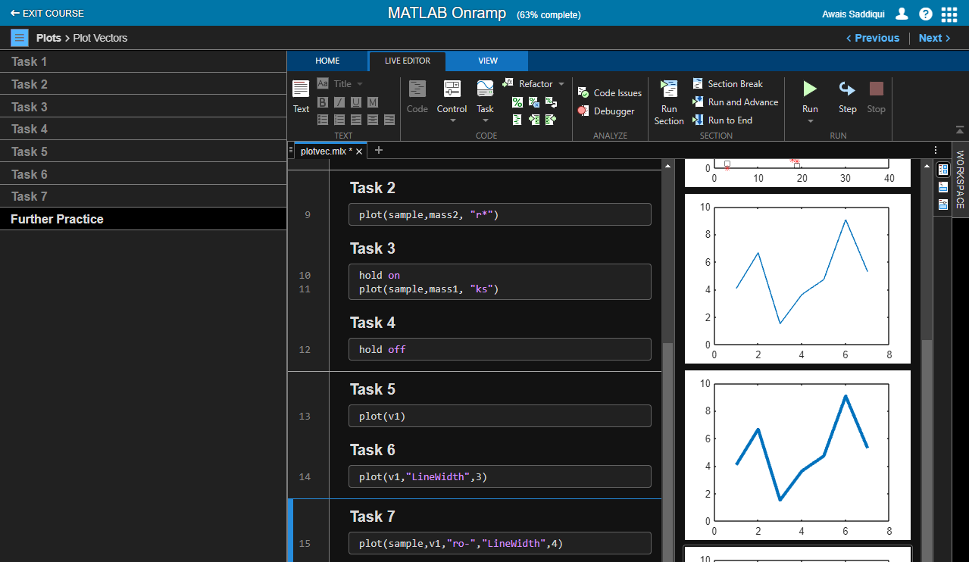

**Remarks**:

In this section I learned how to plot vectors and annotate vectors.

1. **MATLAB Scripts:**

**Objective**: Write and save your own MATLAB programs

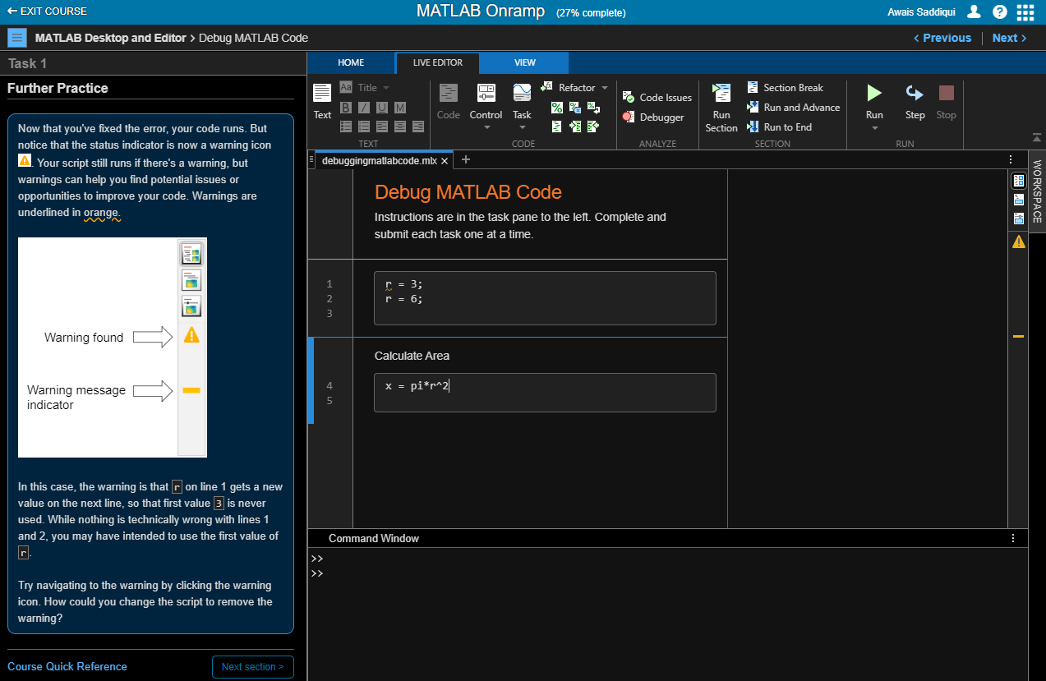

**Remarks**:

How to write and save code in MATLAB.

1. **Logical Arrays:**

**Objective**: Use logical expressions to help you to extract elements of interest from MATLAB arrays.

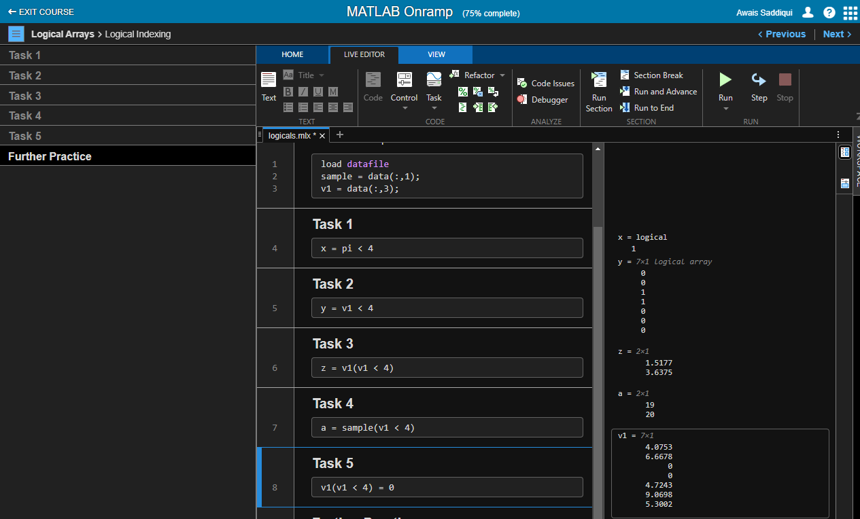

**Remarks:** I learned how to logically index arrays.

1. **Programming:**

**Objective**: Write programs that execute code based upon some condition.

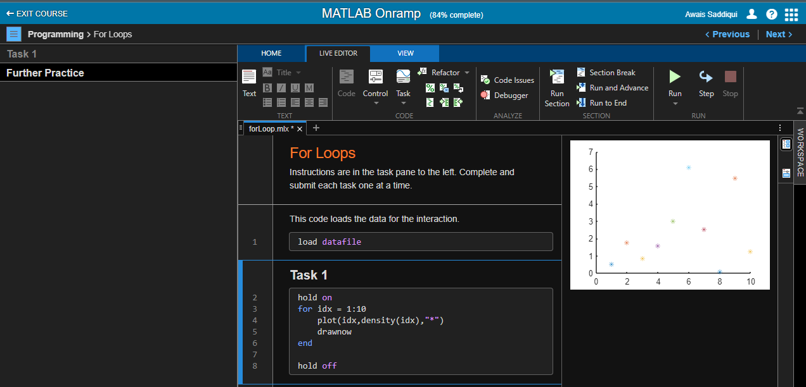

**Remarks:** In this section I learned decision branching and for loops.

1. **Final Project:**

**Objective**: Bring together concepts that you have learned with a project.

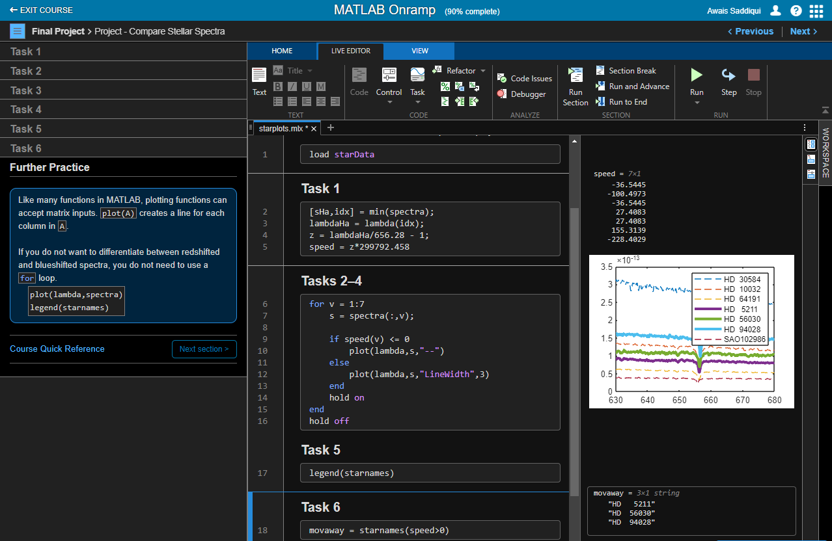

**Remarks:**

In project Steller Motion, when the star is moving away from earth then find It’s wavelength and in second project compare stellar spectra find the speed at which star is moving away.

1. **MathWorks Certificate:**

